**Expense Policy – Entertainment**

**Per Person Limit**

**Enhancement**

Contents

1. Existing Flow: 3

2. Proposed Flow: 4

# Existing Flow:

1. Currently, Finance Manger is able to Edit/change the Effective From Date of the Entertainment Per Person Limit Policy to current and future date only.
2. The Policy applied on the current date is coming under Current Policy and the category is suffixed with CP.
3. The Policy applied on the Future date is coming under Future Policy and the category is suffixed with FP.
4. Finance Manager is not able to select the previous date. (**Screen 1**)

Screen

# Proposed Flow:

1. Finance Manager should be able to select previous and Future date both at the time of editing the Effective from Date. (**Screen 2**)

Screen

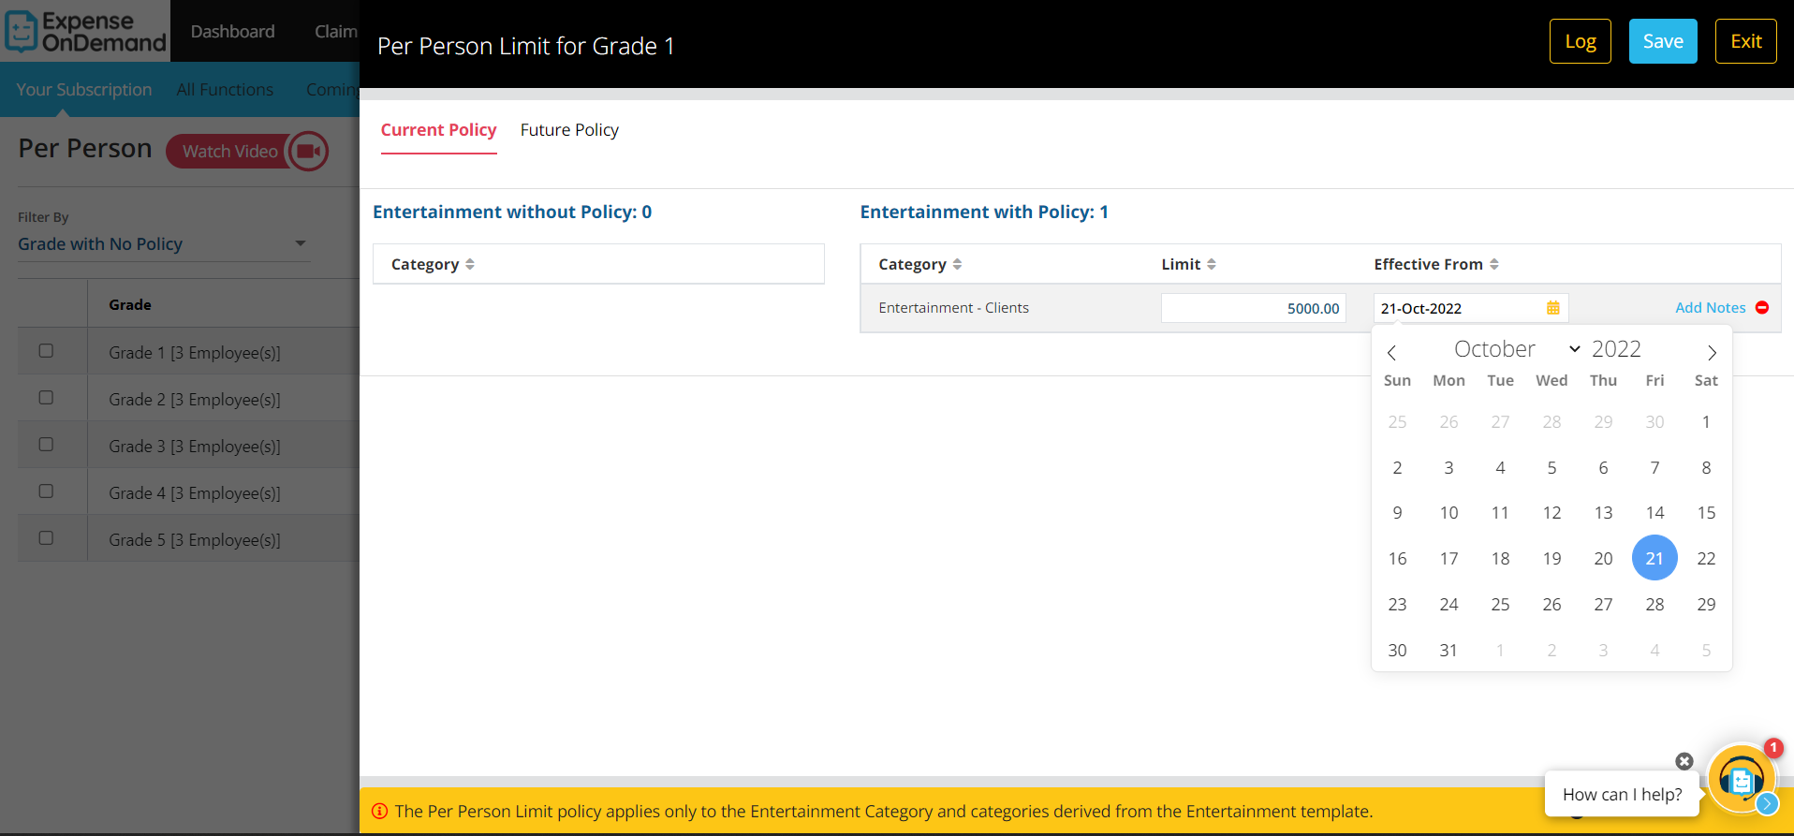

1. If Finance Manager is changing the amount, then he should be able to edit/change the Effective From Date of the Entertainment Per Person Limit Policy to current and future date only. (**Screen3**)

Screen

